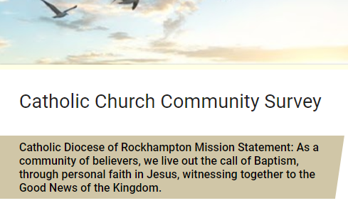

What is the key role of the priest / ordained?  Select all that you believe to be true.  O Spiritual pastor  O Sacramental celebrator  O Preach to the community  O Unifying member of the faith community  O Model of service  O Administrator of parish committees and groups  O Maintenance coordinator  O Hospital visitation  O Other: ________________ | What is my role as a follower of Jesus?  Select all that you believe to be true.  O Attend mass on Sunday  O Daily prayer  O Involved in lay ministry  O Involved in service opportunities  O Supporting my family in my faith  O Evangelisation  O Praying for the church and others  O Celebrating the sacraments  O Supporting the priests  O Works of mercy  O Other: ________________ | What can I do to enrich and enliven the prayer life of the church for example mass?  Select all that you believe to be true.  O Offer my time and talents  O Sing and say the responses in mass  O Prepare for mass  O Be silent during mass  O Welcome people  O Invite people to mass  O Bring children  O Support Children’s liturgy  O Other: ________________

How do we best invite people to come and see Jesus and the Church?
______________________________________________________________________________
______________________________________________________________________________
______________________________________________________________________________

How do we best understand and share our faith?
______________________________________________________________________________
______________________________________________________________________________
______________________________________________________________________________

How can we help people fall in love with Jesus?
(Young people, single people, families, older people, parents, people from other cultures, others).
______________________________________________________________________________
______________________________________________________________________________
______________________________________________________________________________
How can we use technology to enhance faith and connect people?
______________________________________________________________________________
______________________________________________________________________________
______________________________________________________________________________

How can schools and parishes be better connected?
______________________________________________________________________________
______________________________________________________________________________
______________________________________________________________________________

How do we embrace the different types of prayer and spiritualities that are emerging in our communities?
______________________________________________________________________________
______________________________________________________________________________
______________________________________________________________________________

How do we create a missionary church?
______________________________________________________________________________
______________________________________________________________________________
______________________________________________________________________________

Is there any other topic that you would like to comment on?
______________________________________________________________________________
______________________________________________________________________________
______________________________________________________________________________
